Packet Tracer – Configuring Syslog and NTP

1. Topology

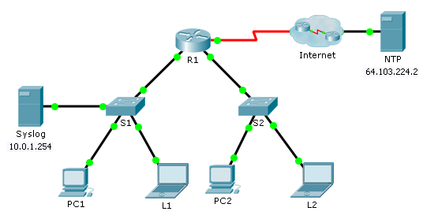

1. Objectives

Part 1: Configure Syslog Service

Part 2: Generate Logged Events

Part 3: Manually Set Switch Clocks

Part 4: Configure NTP Service

Part 5: Verify Timestamped Logs

1. Scenario

In this activity, you will enable and use the Syslog service and the NTP service so that the network administrator is able to monitor the network more effectively.

1. Configure Syslog Service
   1. Enable the Syslog service.
      1. Click **Syslog**, then **Services** tab.
      2. Turn the **Syslog** service on and move the window so you can monitor activity.
   2. Configure the intermediary devices to use the Syslog service.
      1. Configure **R1** to send log events to the **Syslog** server.

R1(config)# **logging 10.0.1.254**

* + 1. Configure **S1** to send log events to the **Syslog** server.

**S1 (config) # logging 10.0.1.254**

* + 1. Configure **S2** to send log events to the **Syslog** server.

**S2 (config) # logging 10.0.1.254**

1. Generate Logged Events
   1. Change the status of interfaces to create event logs.
      1. Configure a Loopback 0 interface on **R1** then disable it.

**R1(config)# interface loopback 0**

**R1(config-if)# shutdown**

* + 1. Turn off **PC1** and **PC2**. Turn them on again.
  1. Examine the Syslog events.
     1. Look at the Syslog events. **Note**: All of the events have been recorded; however, the time stamps are incorrect.
     2. Clear the log before proceeding to the next part.

1. Manually Set Switch Clocks
   1. Manually set the clocks on the switches.

Manually set the clock on **S1** and **S2** to the current date and approximate time. An example is provided.

S1# **clock set 11:47:00 July 10 2013**

* 1. Enable the logging timestamp service on the switches.

Configure **S1** and **S2** to send its timestamp with logs it sends to the **Syslog** server.

S1(config)# **service timestamps log datetime msec**

**S2(config)# service timestamps log datetime msec**

1. Configure NTP Service
   1. Enable the NTP service.

In this activity, we are assuming that the NTP service is being hosted on a public Internet server. If the NTP server was private, authentication could also be used.

* + 1. Open the **Services** tab of the **NTP** server.
    2. Turn the NTP service on and note the date and time that is displayed.
  1. Automatically set the clock on the router.

Set the clock on **R1** to the date and time according to the NTP server.

R1(config)# **ntp server 64.103.224.2**

* 1. Enable the logging timestamp service of the router.

Configure **R1** to send its timestamp with the logs that it sends to the **Syslog** server.

**R1(config)# service timestamps log datetime msec**

1. Verify Timestamped Logs
   1. Change the status of interfaces to create event logs.
      1. Re-enable and then disable the Loopback 0 interface on R1.

**R1(config)# interface loopback 0**

**R1(config-if)# no shutdown**

**R1(config-if)# shutdown**

* + 1. Turn off laptops **L1** and **L2**. Turn them on again.
  1. Examine the Syslog events.

Look at the Syslog events. **Note**: All of the events have been recorded and the time stamps are correct as configured. **Note**: **R1** uses the clock settings from the NTP server, and **S1** and **S2** use the clock settings configured by you in Part 3.